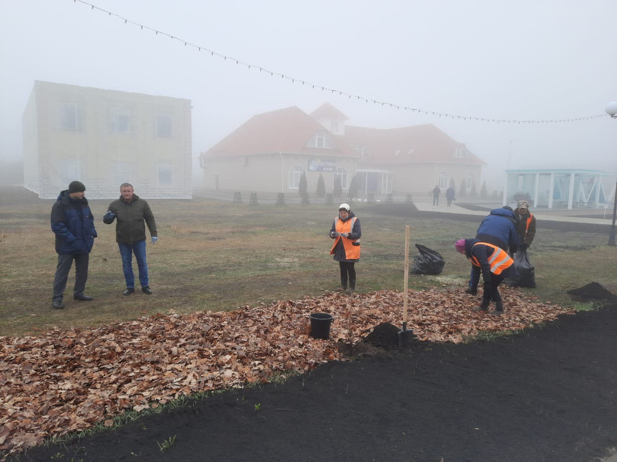C:\Users\Санек\AppData\Local\Microsoft\Windows\Temporary Internet Files\Content.Word\PNDC1754.jpgC:\Users\Санек\AppData\Local\Microsoft\Windows\Temporary Internet Files\Content.Word\WKZD0612.jpg