C:\Users\Санек\AppData\Local\Microsoft\Windows\Temporary Internet Files\Content.Word\BTHA0777.jpg

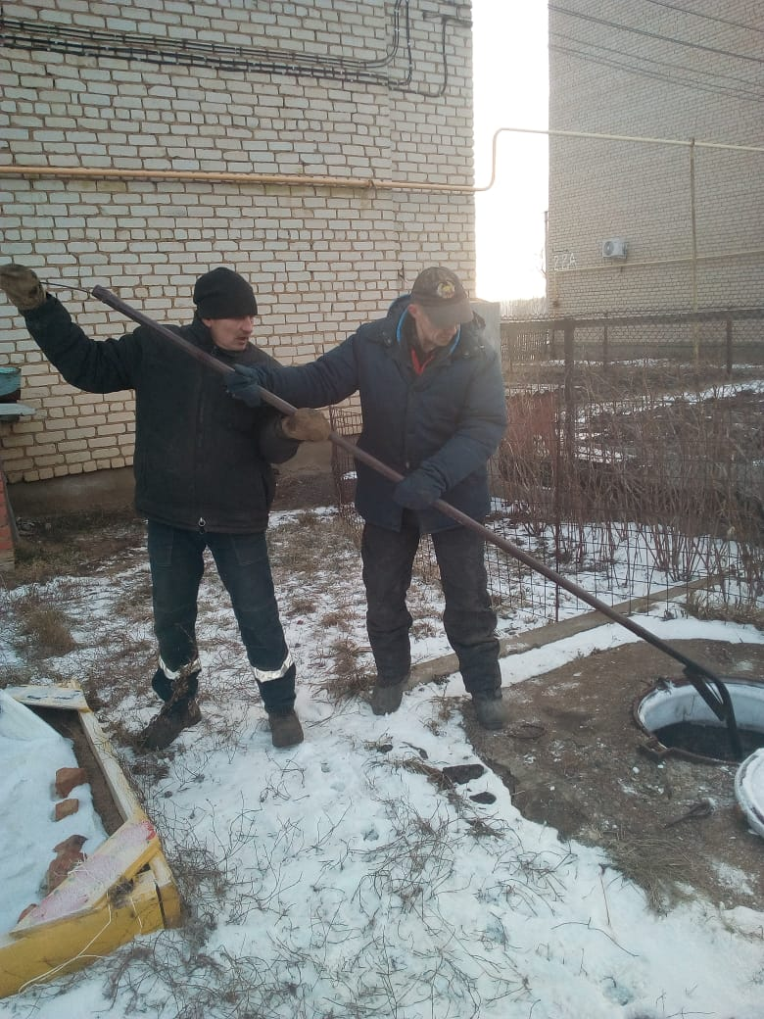

C:\Users\Санек\AppData\Local\Microsoft\Windows\Temporary Internet Files\Content.Word\KACO4732.jpg

C:\Users\Санек\AppData\Local\Microsoft\Windows\Temporary Internet Files\Content.Word\WVMM3762.jpg